Neptune and Collective Mythologies
In a strange way, the world becomes what we collectively imagine it to be. You could say this is a definition of mythology. We have stories about ourselves, about the world and about the universe. Science, which provides the modern worldview, is no different. It has 2 big Creation Myths: the Big Bang (the Universe) and Evolution (Life). It also believes that its stories are not stories, unlike every other culture’s stories.
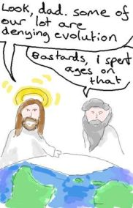
The assumptions behind the science story (at its worst) are that the universe is a material object ‘out there’ to be studied, that it is fully comprehensible by human reason alone and that it is inanimate and indifferent to us. Any other stories are the product of primitive minds. Huge, cold assumptions.
Jupiter is the planet of story-telling. But I think that Neptune, the planet of the Imagination, is the ocean out of which the stories are picked. Neptune is that place where consciousness and matter merge, where it becomes obvious that you cannot separate human consciousness and the universe that consciousness is always trying to understand and describe.

So our stories in a sense create the world, and it makes Neptune a very fundamental planet. We usually think of Neptune as fashion, as addiction, as creativity, as redemption, as a sense of connectedness. And all this is true. But underneath it all Neptune describes the sort of world in which all this takes place, the sort of world that the collective imagination has in fact created. It may be a beautiful, harmonious vision of the universe in which humanity and nature live in balance and flourish.

Or it may be a nightmare vision of master races and dominance of nature by divine edict. I think that in the West we probably have to go back to pre-Christian times to find a healthy collective mythology. We have forgotten what it is like.
Neptune was discovered in 1846, so its placement then tells us a lot about the world people imagined they lived in at the time. The Discovery chart (see below) has Neptune stationing conjunct Saturn in the 10th House at 26 Aquarius. So the Universe was becoming scientific (Aquarius), with man, rather than God, at the top of it. Aquarius supports humanity’s intellectual gifts, but is also prone to hubris. Prometheus was a very Aquarian figure. He brought all sorts of gifts to mankind, and Zeus told him not to bring Fire, but he did, and was punished for it. Prometheus had a disregard for Zeus as the embodiment of the laws of nature.

1846 was before Darwin’s book on the Origin of Species was published, but the idea of Evolution was already becoming known and gaining credibility in the academic world. So it was entering the collective imagination, and is well described by Neptune in Aquarius. Evolution is a scientific Creation Myth that puts Man at the pinnacle of Creation, continuing the sense of dominance over nature that was granted by the God of the Old Testament. Neptune’s close conjunction to Saturn in the 10th House reinforces this sense of dominance. Neptune stationing (standing still) is like him staring at us, saying you really need to look at this.
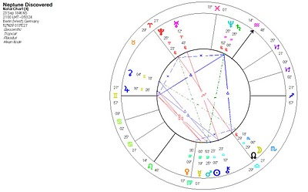
In the last few years we have had the 1st Neptune Return, in the sense of Neptune reaching the place it was in when it was discovered. We have just had one full Neptune cycle of Science as our underlying collective mythology. So it is not surprising that the imbalances of that mythology are becoming clearer, that we are living in a time when we can no longer ignore the sense of dominance over nature that we have inherited from Christianity, and then had compounded by Science. We are collectively in the position of Prometheus with his liver being pecked out afresh every day.

A healthy mythology has stories about the consequences of humanity’s innate tendency to get above itself. Hubris and its consequences are fundamental to ancient Greek Mythology. You find it also in the Chippewa Cree stories in the figure of Wisahitsa, a figure of fun who is always getting tripped up by his own self-importance. But an understanding of hubris is not part of our modern mythology, which is full of pride at human achievement, at how clever we are.
The Big Bang is the other modern Creation Myth, and that began to gain acceptance in the 1960s, while Neptune was in Scorpio. That is the perfect sign for the Big Bang. Under Scorpio, or Pluto transits, seeds are planted that turn out to have tremendous power, and that is exactly what the Big Bang was. A singularity giving rise to the whole Universe. It is interesting that the Christian Era also began under Neptune in Scorpio, and that has the Creation Myth of God creating the world out of nothing.
The fact that Neptune was discovered under Aquarius suggests that the Myth we need to pay most attention to is the one behind the Big Bang and Evolution, which is the Myth of Science itself and its approach to knowledge, as well as its placement suggesting power and dominance. And it is first of all important to recognize that it is a Myth, in the sense of an underlying story that we have collectively created. This is hard to do, because it is so much presented to us as an undeniable reality. But any Myth worth its salt will have this quality of believability.
Years ago I read a short book called ‘The World is as You Dream It’ by John Perkins. It was based on his experiences with South American Indians, and the title is self-explanatory. Perkins was arguing for the need to re-dream western culture – that, if you like, a new mythology is needed. And I think the Neptune Return is also telling us this.
Neptune changes sign every 14 years or so, describing the ongoing shifts in the stories we tell ourselves about the world we are in. A mere change of sign doesn’t point to a fundamental change in mythology, you need to discover Neptune for that! For some of the significant changes, you probably also need to look at the Progressed Neptune chart, and the changes in direction of Prog Neptune, or the progressed new Moons, for example. In the early 1930s, Prog Neptune reached the position it was in when it was discovered, and there was also a progressed New Moon. And this was the time that Japan and Germany’s master race mythologies changed the world.
Neptune changed signs into Pisces on 3rd/4th April, 2011 (depending on where you live). There is no reason to suppose it will re-dream the whole of western culture, but coming hard on the heels of the Neptune Return, and being in its own sign of Pisces, it may well be more notable than most.
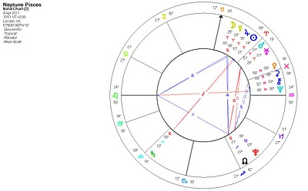
In the last six years we have seen both Pluto (2008) and Uranus (2010) change signs, and this has been quite dramatic. Within days of the 1st Pluto Ingress (entry into a sign) into Capricorn in January 2008, the Stock Market began to rock and the financial crisis got seriously underway. Pluto is a god of wealth, and so rules the economy. On Uranus’ last day in Pisces, there was the biggest recorded earthquake in Japan followed by a tsunami. On his 1st day in Aries (his 2nd and final Ingress), there was an explosion at a Japanese nuclear plant affected by the earthquake.
The Ingresses are not always dramatic, but they remind you that these planets and their signs are real things, that the meaning of human affairs is to be found in the heavens.
The chart for Neptune’s Ingress into Pisces has six planets, including a New Moon, in Aries. This suggests to me that, while our basic mythology may not change, there will still be some big changes to the way we see the world. Neptune in Capricorn, which began in the mid-1980s, was an era in which money (Capricorn) became fashionable (Neptune). Neptune in Aquarius, which began in the late 1990s, began the Internet Age: Aquarius is computers and Neptune is the interconnectedness of the web. Neptune in Pisces. Who knows?
Events near the Ingress can be suggestive. A tsunami occurs in Japan, and the whole world feels involved. The major powers are acting in concert to help the people of Libya. Globalization – the connectedness of Neptune – may move on a step from just business convenience, the globalization of Neptune in Capricorn; and electronic friendships, the globalization of Neptune in Aquarius. Humanity may begin to identify more with the world as a whole. There is a nuclear accident in Japan, no-one has died from it, but both Germany and China call a halt to their nuclear programs. That halt may not last, but it shows how sensitive we have become collectively, even in China, which has an autocratic government that doesn’t have to pay too much attention to its people. If nuclear power takes a hit, and we all know that oil is ultimately limited, then that means we are starting to tell ourselves a different story about our relationship to the earth, that we are planning to move towards clean, renewable sources. Not only is that sensible for practical reasons, but it creates a new mythology in which we can no longer dominate in the way we have become used to. It means we can only take from the earth that which she can renew, which our ancestors – and anyone with half a brain – always knew. But it is not just knowledge, it re- creates a feeling relationship that has been forgotten. And when you have knowledge and feeling working as one, then you have a new imaginative relationship, you have a new mythology. So I think that Neptune in Pisces will bring this in to some extent, even in the USA (which is notable for not changing its nuclear policy and not wanting to curb its greenhouse gases.)

