Further Reflections on Triplicity Lords
Posted on May 25, 2020 by Anthony Louis

In the previous post I commented on a view of triplicity rulers that was prevalent in the 15th century. Having recently watched an interview with Jenn Zahrt done by Mychal A. Bryan, I was interested in comparing what Jenn had to say with the 1485 text of Diego of Torres who taught astrology to university students in Salamanca. One of the comments that Jenn made, which garnered a lot of interest, was the idea that the third triplicity lord of the 9th house had to do with one’s relationship to astrology and divination.
For those unfamiliar with triplicity rulers, let me give a brief overview. Triplcity is one of the five so-called essential dignities of Western astrology. Most astrologers are familiar with dignity by domicile, the home sign(s) of a planet. For example, the home signs or domiciles of Mercury are Gemini and Virgo. A planet’s home is his castle, where he rules and decides what happens there. The next essential dignity is exaltation, where a planet is “raised on high” and treated like an honored and distinguished guest. Planets that are placed at such a high or powerful level usually feel quite happy about it, but sometimes it can “go to their heads” and they can become somewhat haughty or arrogant.
The third essential dignity is triplicity, which refers to a type of rulership related to the elemental nature of the signs (Fire, Earth, Air, Water). Each element is allotted a community of three triplicity lords, one that comes first in day charts, one that comes first in night charts and one that come in third all the time. The Fire and Air signs are considered diurnal, masculine, yang or of positive valence, and their lords come from the group of diurnal planets: Sun, Saturn, Jupiter, and Mercury which rules and Air sign and is diurnal when it rises before the Sun. The Earth and Water signs are considered nocturnal, feminine, yin and of negative valence, and their lords come from the community of nocturnal: Moon, Venus, Mars. Even though Mercury rules Virgo, an Earth sign, and is nocturnal when it rises after the Sun, Mercury is omitted from the group of nocturnal triplicity rulers. Thus, the traditional scheme of triplcity rulership looks like this:
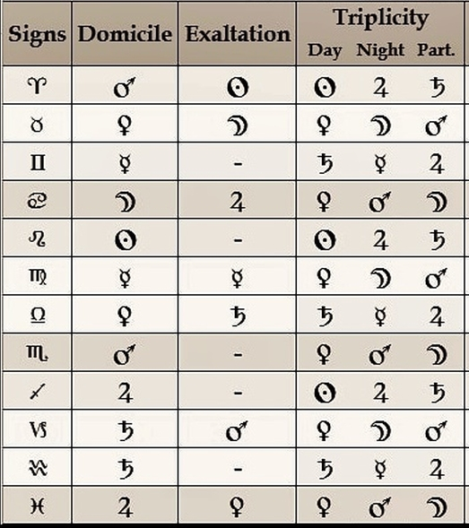
The fourth essential dignity is called term or bound, and it refers to divisions of signs into five unequal parts, each of which is ruled by a non-luminary visible planet. William Lilly used the terms or bounds as descriptors of the physical appearance of clients and as symbols of material manifestation. In a sense the terms are like your extended kin who bear some physical resemblance to you because they are blood relations.
The fifth essential dignity is called face or decan. Face is the weakest of the essential dignities. Jenn Zahrt mentions that in Renaissance astrology the dignity of face by analogy is like a stranger who is allowed to stay in a foreign land because he or she possesses some special skill or talent.
Triplicity Lords in Chart Delineation
Many astrologers primarily utilize the domicile lord of the sign on the cusp of a house to signify the matters assigned to that house. Two millennia ago Dorotheus proposed using the triplicity lords to futher refine the delineation of particular areas of life. A post in Seven Stars Astrology makes it clear that Dorotheus regarded all three triplicity rulers to be active all the time but in a particular order of predominance:
“The triplicity of Aries: its lords by day are the Sun, then Jupiter, then Saturn; and by night Jupiter, then the Sun, then Saturn.” (Dorotheus, Book I, Ch. 1, #4, Dykes trans., 2017, p. 61-62)
In other words, in a day chart, the 3-member community of triplicity lords of the diurnal Fire sign Aries are, in order: Sun, Jupiter, Saturn but …
in a night chart, the 3-member community of triplicity lords of the diurnal Fire sign Aries are, in order: Jupiter, Sun, Saturn, all of which are ruling the Fire triplicity in a nocturnal chart in this order.
It appears that medieval and Renaissance astrologers may have misunderstood Dorotheus and thus mistakenly believed that one of the triplicity rulers got turned off when the Sun went down. Instead, Dorotheus seems to be stating that all three triplicity lord are active all the time but that the first one predominates and is modified by the other two.
A further twist on triplicity lords was to use them to assign the many significations of a house of particular planets which belonged to the triplicity’s 3-lord community. The following is a very brief summary of such a subdivision based on the writings of Al-Andarzaghar (6th century?), Al-Qabisi (Alcabitius, 10th century), Bonatti (13th century) and Diego de Torres (15th century).
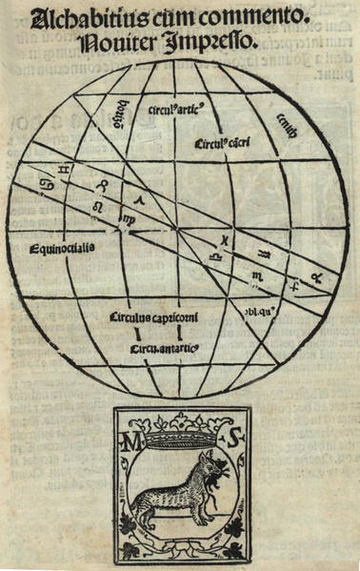
1st House Triplicity Lords:
First Lord: the life, life force, preferences, desires and nature of the native; the first years of life
Second Lord: the life, body and strength of the native; the middle years of life
Third Lord: the life, body and strength of the native, the final years and the end stage of life
2nd House Triplicity Lords:
First Lord: acquiring possessions, wealth at the beginning of life
Second Lord: acquiring possessions, wealth in the middle of life
Third Lord: acquiring possessions, wealth in the later years of the life
3rd House Triplicity Lords:
First Lord: older siblings (born before the native)
Second Lord: middle siblings (close in age to the native)
Third Lord: younger siblings (born after the native)
4th House Triplicity Lords:
First Lord: Parents (father and mother)
Second Lord: lands, countries, real estate
Third Lord: final outcomes, endings, prison, the final period of life, the end of all things
5th House Triplicity Lords:
First Lord: children, offspring
Second Lord: pleasures, vices, enjoyments
Third Lord: messengers, emissaries; giving of gifts for benefit
6th House Triplicity Lords:
First Lord: illness and recovery from illness, sickness, wounds, poor health
Second Lord: slaves, servants, employees
Third Lord: the activity and benefits of slaves/servants/employees to the native, domestic animals, prison and confinement
7th House Triplicity Lords:
First Lord: spouse, intimate partner, women
Second Lord: conflict, controversies, adversarial relationships, open enemies
Third Lord: covenants, formal agreements, business partnerships
8th House Triplicity Lords:
First Lord: death
Second Lord: old matters, ancient things, knowledge from past traditions
Third Lord: inheritances and legacies from the dead
9th House Triplicity Lords:
First Lord: journeys and their suitability
Second Lord: religion, faith, religious observance, eminence in matters of religion
Third Lord: science (higher knowledge), wisdom, vision (premonitions), omens, divination, astrology, and the truth or falsehood of such matters
10th House Triplicity Lords:
First Lord: authority, honor, high rank, governance, career
Second Lord: fame, bravery, the ability to command
Third Lord: the stability and endurance of one’s authority or fame
11th House Triplicity Lords:
First Lord: hopes, things given in trust
Second Lord: friends
Third Lord: benefits from friends, patronage
12th House Triplicity Lords:
First Lord: enemies, secret enemies
Second Lord: fortune, laborers
Third Lord: large animals that you can ride

